Sec. 30-4.8. Development compatibility.

A. *Setbacks.*

1. Whenever a zero foot setback is allowed in a zoning district, it may only be used if the abutting property is within a district that allows the same setback.

2. The minimum required side and rear setback for nonresidential buildings located on property abutting a single-family zoning district or the U1 district shall be the same as the setback required on the adjacent residential lot or as determined by the required buffer, whichever is greater.

B. *Limitations on uses.* All industrial or commercial activity and uses, except storage of equipment and parking, shall be conducted within completely enclosed buildings when located within 300 feet of any property that is in a single-family zoning district or the U1 district.

C. *Building height and massing.*

|  |  |  |  |
| --- | --- | --- | --- |
| **Within 50' of the Following Districts:** | **Max. Building Height** | | |
| Single-Family Zoning | 3 stories and 36' | Building facades shall not exceed 60' unless a substantial volume break is provided, such as a volume recess with a minimum 4' depth. | |
| U1 |  |
|  |
|  |  |
|  |  | | |
| •. | | |
| **Within the Following Districts:** | **Max. Building Height** | | |
| Pleasant Street Historic District | 3 stories and 36' | | |
| Power District | 6 stories, but  3 stories when adjacent to residential zoning, with a step-back of 15' per additional building story up to max. permitted. | | |

Figure 1: Height Compatibility Pitched Roof Example

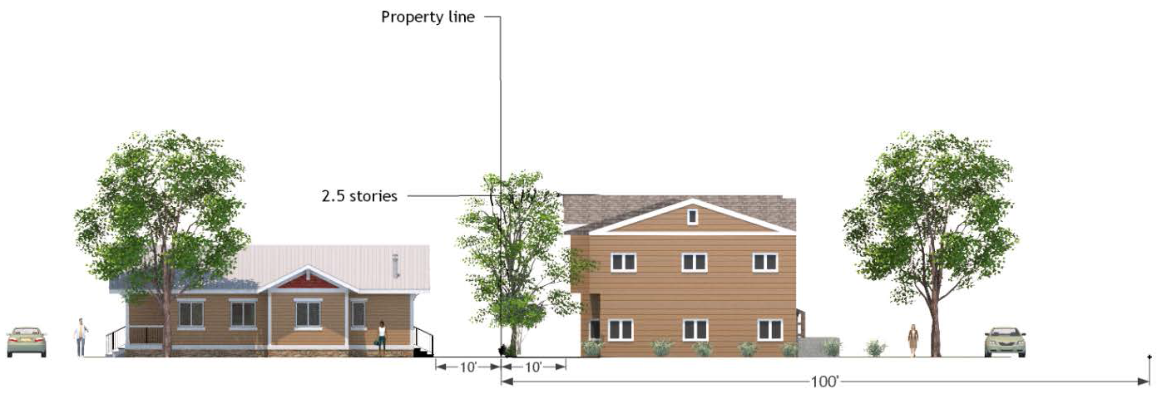

Figure 2: Height Compatibility Flat Roof Example

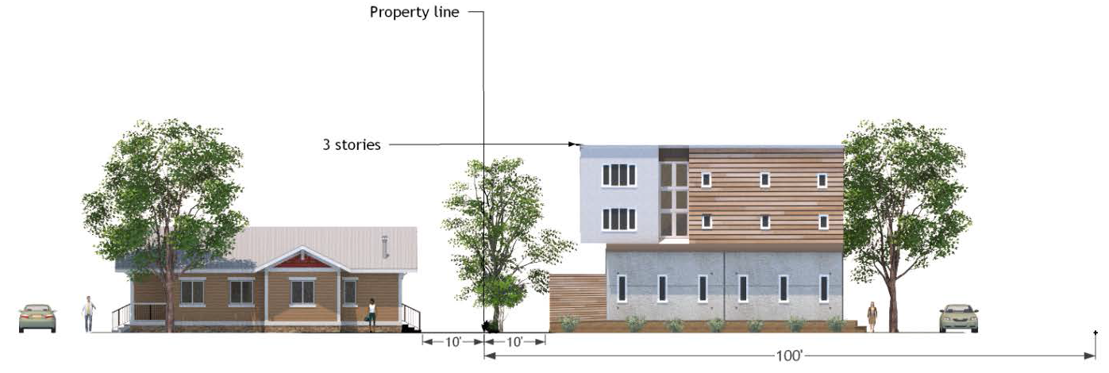

Figure 2: Height Compatibility University Heights

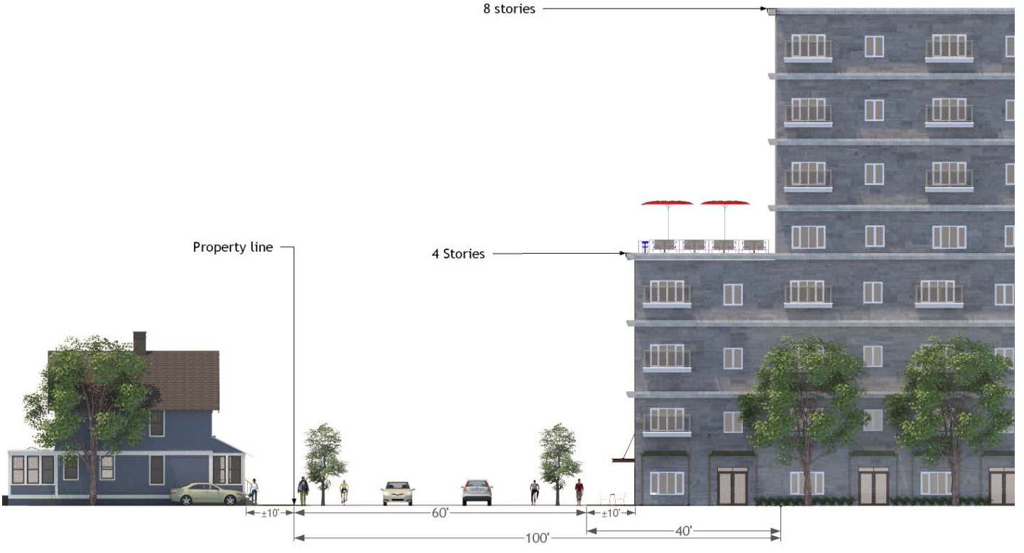

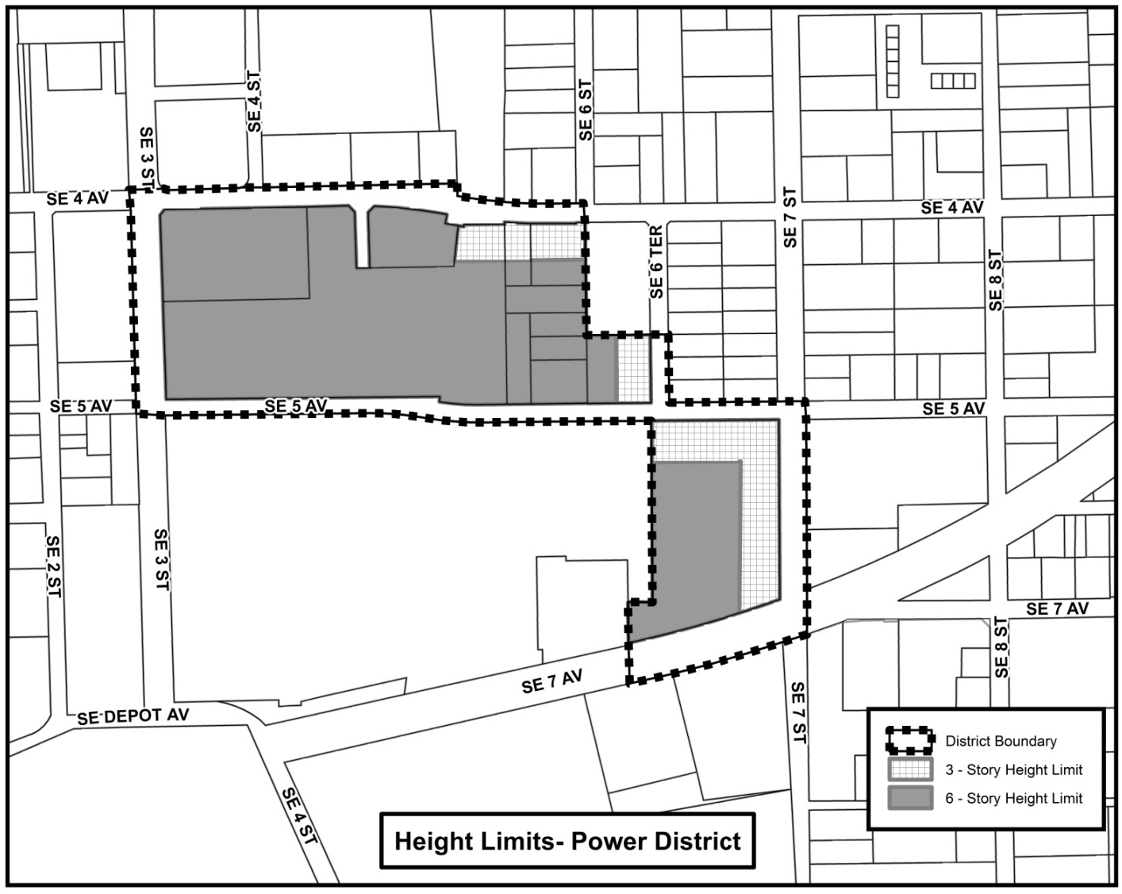

D. *Multi-family developments.*

1. *Generally.* Multi-family development shall contain no more than six dwelling units per building and shall be in the form of single-family dwellings, attached dwellings, or small-scale multi-family when located within 100 feet of any property that is in a single-family zoning district.

2. *Abutting single-family property.* All new multi-family projects, whether stand alone or part of a mixed-use project, abutting property in a residential district or a planned development district with predominantly residential uses shall comply with the following regulations:

a. There shall be no outdoor recreation areas or uses allowed within any required building setback area or landscape buffer between abutting multi-family development and single-family designated properties.

b. Active recreation areas (including swimming pools, tennis courts, basketball, and volleyball courts) shall be located away from abutting single-family designated properties and shall be oriented in the development to minimize noise impacts on single-family designated properties.

c. There shall be no car washing areas, dumpsters, recycling bins, or other trash/waste disposal facilities placed in the required setback area between multi-family development and properties zoned for single-family use.

d. Parking lots and driveways located in the area between multi-family and abutting single-family designated properties shall be limited to a single-loaded row of parking and a two-way driveway.

e. A decorative masonry wall (or equivalent material in noise attenuation and visual screening) with a minimum height of six feet and a maximum height of eight feet plus a Type B landscape buffer shall separate multi-family residential development from properties designated single-family residential. However, driveways, emergency vehicle access, or pedestrian/bicycle access may interrupt a continuous wall. If, in the professional judgment of city staff or other professional experts, masonry wall construction would damage or endanger significant trees or other natural features, the appropriate reviewing authority may authorize the use of a fence and/or additional landscape buffer area to substitute for the required masonry wall. There shall be no requirement for a masonry wall or equivalent if buildings are 200 or more feet from abutting single-family properties. In addition, the appropriate reviewing authority may allow an increased vegetative buffer and tree requirement to substitute for the required masonry wall.

f. The primary driveway access shall be on a collector or arterial street, if available. Secondary ingress/egress and emergency access may be on or from local streets.

3. *Bedroom limit.* Maximum number of bedrooms in multi-family developments located within the University of Florida Context Area.

a. Multi-family developments shall be limited to a maximum number of bedrooms based on the development's maximum residential density allowed by the zoning district multiplied by a 2.75 multiplier.

b. If additional density is approved through a special use permit, then the multiplier is applied to the total approved density inclusive of any additional units approved by special use permit.

c. The bedroom mix in the development (i.e., the number of units with a specific number of bedrooms) is not regulated by those provisions.

d. Developments with planned development (PD) zoning are not subject to the bedroom multiplier.

(Ord. No. 170974, § 5, 2-21-19; Ord. No. 211359, § 4, 10-17-22; Ord. No. 2023-169, § 4, 6-1-23)